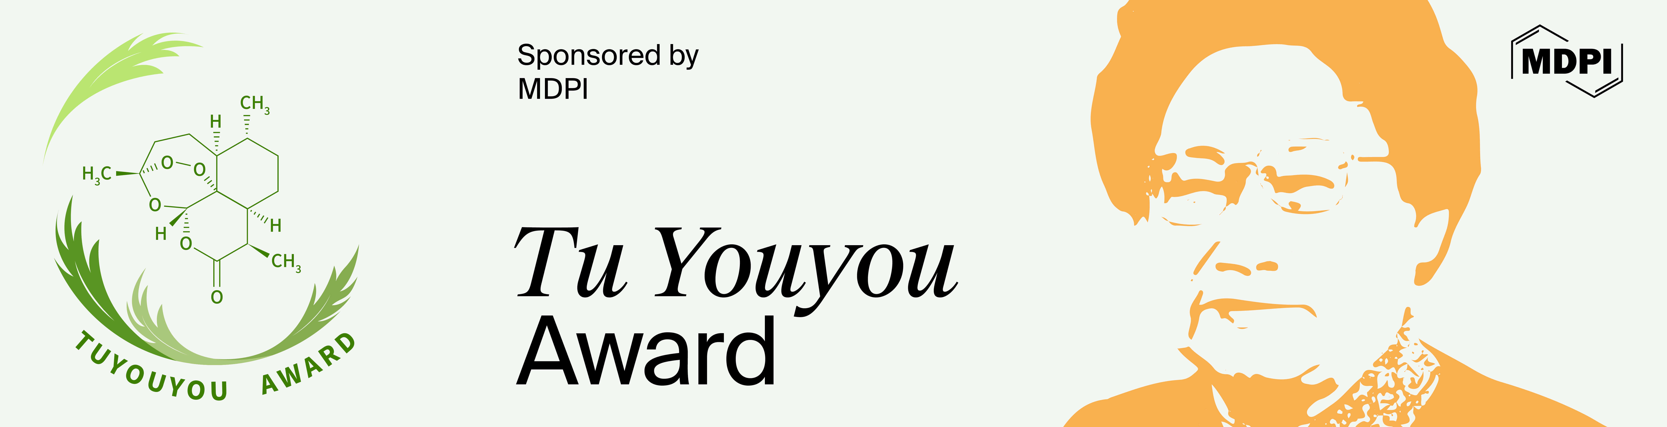

Prof. Dr. A. Douglas Kinghorn Appointed as the Chair of the 2024 Tu Youyou Award Committee

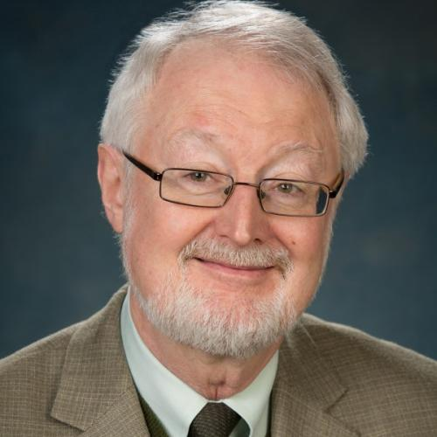 | Prof. Dr. A. Douglas Kinghorn
College of Pharmacy,
The Ohio State University, USA

It is a great honor to announce that Prof. Dr. A. Douglas Kinghorn will serve as the Chair of the Award Committee for the 2024 Tu Youyou Award.

Professor Kinghorn is a leading expert in pharmacognosy and natural products research. He is recognized for his key contributions to discovering bioactive compounds from plants, especially in anticancer, cancer chemopreventive, and substances with a sweet taste and taste-modifying agents. With extensive experience, he has published over 590 peer-reviewed works and book chapters and has edited or co-edited 40 scientific volumes.

As the Chair of the 2024 Tu Youyou Award Committee, Professor Kinghorn will be instrumental in recognizing exceptional contributions to the fields of natural products chemistry and medicinal chemistry. The committee will aim to identify innovative research that has the potential to lead to significant advancements in these areas. We believe the award will continue to grow in prestige and importance under his leadership.

About Tu Youyou Award
Established in 2016, the Tu Youyou Award seeks to honor scholars who excel in the fields of natural products chemistry and medicinal chemistry. This award offers a total prize of CHF 100,000, which will be equally divided among winners if there is more than one, with each recipient receiving an award medal.

The Tu Youyou Award will remain open for nominations until December 31, 2024. We encourage all eligible candidates to participate in this prestigious recognition, as it not only honors individual achievements but also encourages further scientific exploration and discovery in critical areas of medicine.

If you are interested in participating, please visit the Tu Youyou Award website for more information on nomination requirements.

